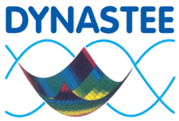
Annex 71

Practical information
Wednesday 10 April; 13:00 – Thursday 11 April; 13:00, 2019 in Bilbao, Spain

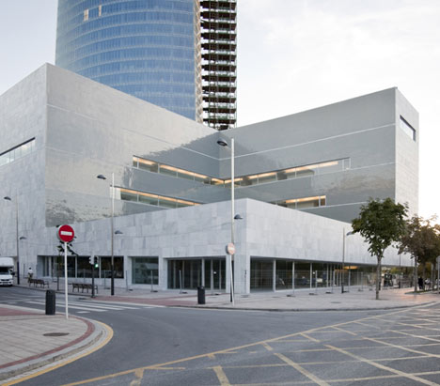
Venue
The symposium will take place in the conference centre BIZKAIA ARETOA (Symposium room BAROJA) nearby the famous Guggenheim Museum.
Address: BIZKAIA ARETOA, Avenida Abandoibarra, 3, 48009, Bilbao

Cost and registration
Participation to the symposium is free, but requires you to register for the event

Download the symposium registration form from the www.dynastee.info web-site and mail it to sd@bbri.be or register on line with the google form https://docs.google.com/forms/d/e/1FAIpQLSepKVnrJNTueWGj9mD5zpieYW2ted7cSZdqQKlxuwe2oEyp9w/viewform

The number of seats is limited to 120, you will receive an official confirmation from sd@bbri.be after registration on line or by e-mail.

Traveling to Bilbao is easy. The inviting city is connected to most major cities by many air companies in Europe. The airport is situated close to the city centre. There are many Hotels and B&B in the city, not far from the venue.

About DYNASTEE www.dynastee.info
DYNASTEE is a platform for information exchange on dynamic analysis, simulation and testing of the energy performance of buildings. DYNASTEE is closely linked to the activities of the IEA ECB Annex 71 project; it is responsible for the subtask on dissemination and the Network of Excellence. This is done through activities such as training of researchers on dynamic methods (Summer School), bringing its expertise from earlier projects (PASSYS-PASLINK) into the Annex 71 project, publication of a newsletter and a website, and organising workshops and webinars.

About INIVE www.inive.org
INIVE EEIG (International Network for Information on Ventilation and Energy Performance), a European Economic Interest Grouping has 9 member organisations (BBRI, CETIAT, CSTB, eERG, IBP-Fraunhofer, SINTEF, NKUA, TMT US and TNO) (www.inive.org ). INIVE is coordinating and/or facilitating various international projects, e.g. the AIVC (www.aivc.org ), TightVent Europe (www.tightvent.eu ), venticool (www.venticool.eu) and DYNASTEE (www.dynastee.info ).

